A
Project Based Learning – Project Report
on

“Li-Fi
[Data Transmission Through Light]”

Submitted by
Mr. Sourabh Shende

Under the guidance of
Prof. Aarti Shinde



Department of First Year Engineering
Dhole Patil College of Engineering,
Wagholi, Pune- 412207

2023-2024

Dhole Patil College of Engineering,
Wagholi, Pune- 412207




This is to certify that Mr. Sourabh Shende has successfully completed the Project Based Learning – Project Report entitled “Li-Fi [Data Transmission Through Light]” under my supervision, in the partial fulfillment of First Year of Engineering in Savitribai Phule Pune university.

Date:

Place:

Prof. Aarti Shinde Prof. Omkar Gangatire Dr. Gopal Alapure
Guide’s name Coordinator FE Incharge

ACKNOWLEDGEMENT
With the deep sense of gratitude, I wish to express my sincere thanks to my guide, Prof. Aarti Shinde, for her immense help in planning & executing the work in time. The confidence & dynamism with which she guided the work requires no elaboration. Profound knowledge & timely guidance with came as a boon from her which helped me in completing our project successfully. Her valuable suggestions as final words during the course of work are greatly acknowledged. Whatever I know today about the process of research, I learned from them. This will be the lifelong remember thing off hard work & dedication to this project in which I was inspired by them. I really feel myself fortunate as we got the opportunity to work with them.
My sincere thanks to Prof. Omkar Gangatire, Coordinator, DPCOE and Dr. Gopal Alapure, First Year Incharge, DPCOE for providing me guidance and constant encouragement. The valuable suggestions & enormous support which I got from them will be life time remembrances.

Mr. Sourabh Shende

TABLE OF CONTENTS

1.INTRODUCTION
2.AIM AND OBJECTIVES
3.LITERATURE REVIEW
4.TECHNOLOGY BRIEF
5.ADVANTAGES AND DISADVANTAGES
6.APPLICATIONS
7.HOW LIFI IS DIFFERENT FROM WIFI
8.CONCULUSION

CHAPTER 1

INTRODUCTION
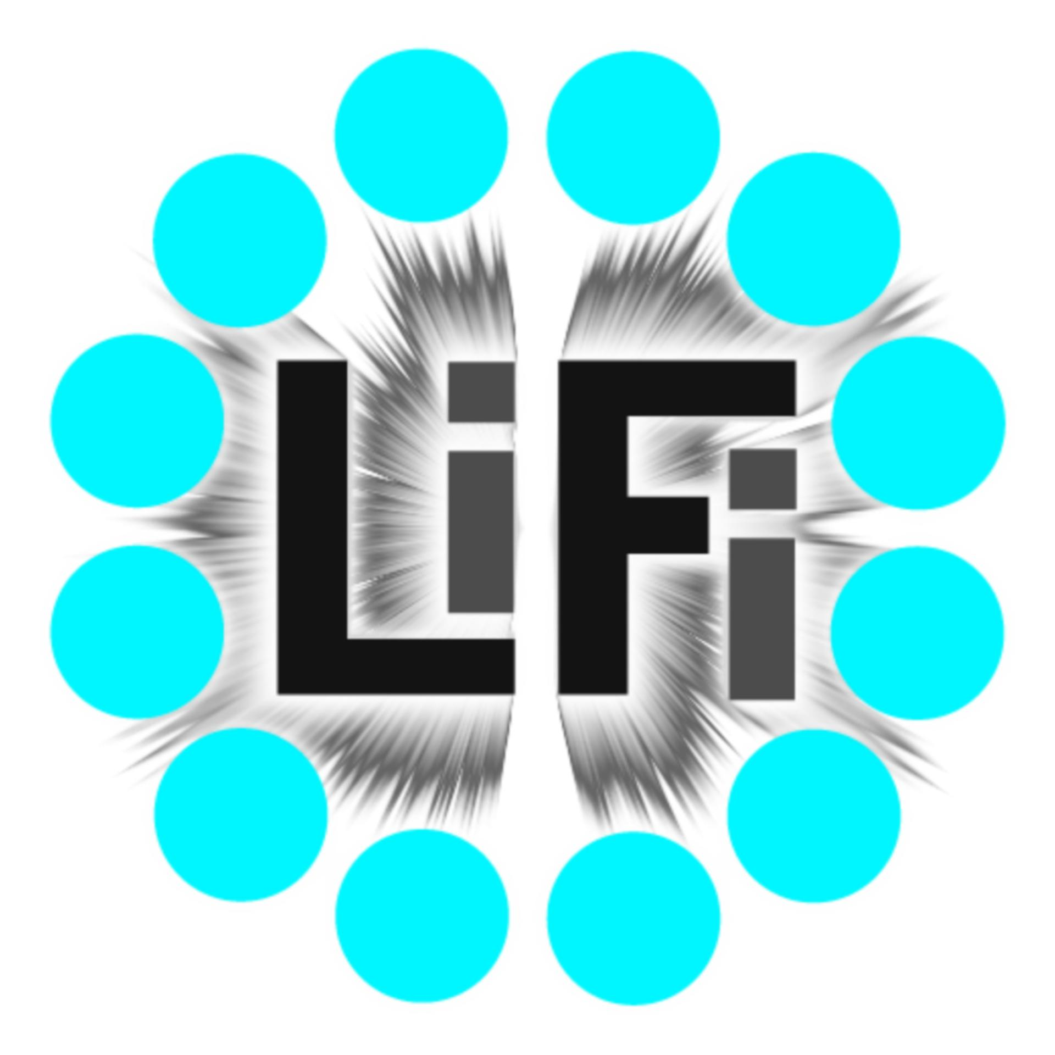
In the digital age, where connectivity is the lifeblood of modern society, the quest for innovative wireless communication technologies has led to the emergence of Light Fidelity (LiFi). LiFi represents a pioneering advancement that harnesses light waves to transmit data, offering a compelling alternative or augmentation to conventional radio frequency-based wireless communication systems like WiFi.
Proposed by Professor Harald Haas of the University of Edinburgh in 2011, LiFi leverages the concept of visible light communication (VLC) and/or infrared light to achieve data transmission at remarkable speeds. At its core, LiFi involves the modulation of the intensity of light emitted by Light-Emitting Diode (LED) bulbs at high frequencies, imperceptible to the human eye, to encode digital information. Specialized photodetectors receive these modulations, decode them, and convert them back into usable data.The advantages of LiFi over traditional WiFi technologies are manifold. As the radio frequency spectrum becomes increasingly congested, LiFi offers a novel solution that operates in the unutilized spectrum of visible light. This circumvents the interference issues that often plague WiFi networks, particularly in densely populated urban environments or areas with high electronic device density. Moreover, LiFi boasts significantly higher data transfer rates, potentially reaching speeds of several gigabits per second, a vast improvement over existing WiFi standards. This remarkable speed opens doors to applications requiring ultra-fast data transmission, such as high-definition video streaming, virtual reality experiences, and real-time data analytics.
Beyond its speed and reliability, LiFi presents unique opportunities for secure communication. Unlike radio waves used in WiFi, which can penetrate walls and propagate over long distances, light waves are confined within a specific area, enhancing the security of LiFi networks. This property makes LiFi particularly suitable for environments where data privacy and confidentiality are paramount, such as corporate offices, government facilities, and military installations.
The versatility of LiFi extends beyond traditional data communication. Its integration with smart lighting systems enables dual functionality, transforming luminaires into data transmitters while fulfilling their primary purpose of illuminating spaces. This convergence of illumination and information opens avenues for innovative applications, including indoor positioning and navigation, context-aware services, and seamless connectivity in IoT ecosystems.
As LiFi technology continues to mature and gain traction, its potential impact on various sectors becomes increasingly apparent. From telecommunications and healthcare to transportation and entertainment, LiFi holds the promise of revolutionizing how we perceive and interact with wireless networks, ushering in an era of unprecedented connectivity and innovation

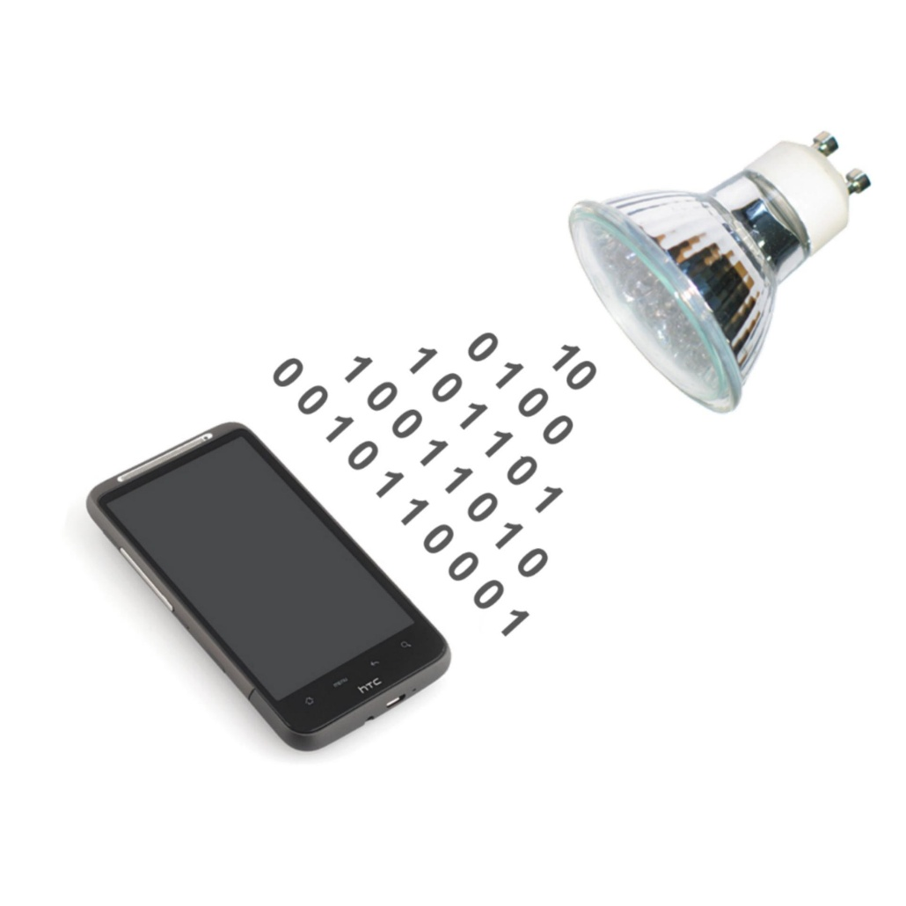
CHAPTER 2
AIM AND OBJECTIVES

Aim:
The primary aim of this report is to comprehensively explore the principles, applications, challenges, and future prospects of Light Fidelity (LiFi) technology, with the overarching goal of fostering a deeper understanding of its transformative potential in the realm of wireless communication.

Objectives:
- Examine the Fundamental Principles of LiFi: This report aims to delve into the fundamental principles underlying LiFi technology, including the physics of visible light communication (VLC), the mechanics of modulation and demodulation, and the intricacies of photodetection. By providing a detailed exploration of these principles, the report seeks to elucidate how LiFi harnesses light waves for data transmission, laying the groundwork for a comprehensive understanding of the technology.

- Investigate Practical Applications Across Various Sectors: Through an extensive review of literature, industry reports, and case studies, this report endeavors to investigate the practical applications of LiFi technology across diverse sectors. From telecommunications and smart infrastructure to healthcare and entertainment, the report aims to showcase real-world implementations of LiFi and highlight its potential to revolutionize connectivity in various domains.

- Identify Current Challenges and Limitations: By critically analyzing existing research, standards, and deployment practices, the report seeks to identify the key challenges and limitations hindering the widespread adoption of LiFi technology. Factors such as signal attenuation, mobility constraints, interoperability issues, and regulatory frameworks will be thoroughly examined to provide a nuanced understanding of the barriers facing LiFi deployment and integration.

- Assess Future Prospects and Emerging Trends: Drawing upon insights from industry experts, technological advancements, and market trends, this report aims to assess the future prospects and emerging trends in LiFi technology. From advancements in LED technology and LiFi-enabled devices to the integration of LiFi with emerging technologies like 5G and artificial intelligence, the report will explore the evolving landscape of wireless communication and its implications for LiFi adoption.

- Provide Recommendations for Adoption and Integration: Based on the findings and analysis, the report endeavors to provide actionable recommendations for the adoption and integration of LiFi technology in various sectors. These recommendations may encompass strategies for addressing technical challenges, fostering collaboration among stakeholders, advocating for regulatory support, and promoting awareness and education about LiFi’s benefits and capabilities.

By pursuing these objectives, this report aims to serve as a comprehensive guide for policymakers, industry stakeholders, researchers, and technology enthusiasts, empowering them to navigate the complexities of LiFi technology and harness its transformative potential to shape the future of wireless communication.

CHAPTER 3
LITERATURE REVIEW
In recent years, Light Fidelity (LiFi) has emerged as a promising technology for wireless communication, offering high-speed data transmission through the use of visible light. This literature review aims to provide a comprehensive overview of the current state of research on LiFi technology, covering various aspects such as technological advancements, application scenarios, and challenges. By synthesizing the findings from recent studies, this review seeks to identify gaps in the existing literature and propose potential future research directions in the field of LiFi.

Technological Advancements in LiFi
The study by Koch et al. (2022) provides strategic insights into the quantum optimal control in quantum technologies, highlighting the advancements in quantum technologies. Furthermore, Siew et al. (2021) offer a comprehensive review of silicon photonics technology and platform development, shedding light on the technological underpinnings of LiFi systems. These findings underscore the importance of continuous innovation and development in the field of LiFi technology, paving the way for enhanced data transmission capabilities and improved reliability.

LiFi in Wireless Networks
Wu et al. (2020) present a survey on hybrid LiFi and WiFi networks, emphasizing the potential integration of LiFi with existing wireless communication systems. The study addresses the coexistence and integration of LiFi and WiFi networks, highlighting the opportunities and challenges associated with such hybrid networks. Additionally, Basnayaka and Haas (2017) discuss the design and analysis of a hybrid radio frequency and visible light communication system, offering insights into the potential synergies between different wireless communication technologies.

LiFi Application Scenarios
Soltani et al. (2018) provide valuable insights into modeling the random orientation of mobile devices, with a specific focus on LiFi use cases. The study offers a detailed analysis of mobile device orientation and its impact on LiFi performance, contributing to the understanding of practical application scenarios for LiFi technology. Moreover, Haas et al. (2019) discuss indoor networking concepts and challenges in LiFi, highlighting the potential for LiFi to be deployed in indoor environments for various communication applications.

Knowledge Gaps and Future Research Directions
While the existing literature provides valuable insights into various aspects of LiFi technology, there are notable knowledge gaps that warrant further investigation. Firstly, there is a need for more research on the practical implementation of LiFi in real-world scenarios, particularly in domains such as smart lighting, Internet of Things (IoT) connectivity, and next-generation wireless networks. Secondly, the interoperability of LiFi with existing communication systems and standards remains a critical area for future research, requiring in-depth studies on coexistence mechanisms and protocol optimization. Lastly, the development of standardized testing methodologies and performance evaluation frameworks for LiFi systems is essential to establish benchmarks and metrics for assessing the quality and reliability of LiFi communication.

In conclusion, the literature on LiFi technology offers valuable insights into the advancements, application scenarios, and challenges associated with this emerging communication paradigm. By addressing the identified knowledge gaps and exploring the suggested future research directions, researchers can further enhance the understanding and practical implementation of LiFi technology in diverse domains.

Overall, the literature review presented here aims to provide a comprehensive overview of the current state of research on LiFi technology, covering various aspects such as technological advancements, application scenarios, and challenges. By synthesizing the findings from recent studies, this review seeks to identify gaps in the existing literature and propose potential future research directions in the field of LiFi.

CHAPTER 4
TECHNOLOGY BRIEF
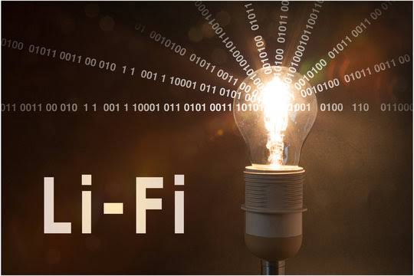

LI-FI CONSTRUCTION:-
The LI-FI product consists of 4 primary sub-assemblies:
- Bulb
- RF power amplifier circuit (PA)
- Printed circuit board (PCB)
- Enclosure
The PCB controls the electrical inputs and outputs of the lamp and houses the
microcontroller used to manage different lamp functions.
An RF (radio-frequency) signal is generated by the solid-state PA and is guided
into an electric field about the bulb.
The high concentration of energy in the electric field vaporizes the contents of the
bulb to a plasma state at the bulb’s center; this controlled plasma generates an
intense source of light. All of these sub assemblies are contained in an aluminum
enclosure.
Transmitters:
The following components are used at the transmitting side:
- Colored LEDs
- Mosfets
- RS232 line driver IC
- USB to RS232 coverter cable
- Voltage Regulator

- COLORED LEDs
An array of Red, Green and Blue LEDs are used at the transmitter end as visible light sources. They are connected as loads in the transistor circuitry. They are high power and emit a focused beam. Each color is used to carry a different data stream.
- MOSFETs
A high speed N-type power MOSFET IRF 520 is used to modulate the LEDs using OOK (On off Keying). The serial output from the computer is converted into TTL Compatible form and is then applied to the gate of the transistor. Thus, it switches The load (LEDs) on and off in accordance with the input data 4.3.1.3 RS232 line Driver
Since the output of computer is RS232 compatible, a 16 pin RS232 line driver IC MAX 232 is used to make the computer output TTL level compatible to drive the Transistor circuit carrying through LED load.
- USB TO RS232 COVERTER CABLE
In laptops, serial port is not available. Since data is to be transmitted serially Between the two computers, a USB to RS232 converter cable is used to interface The serial output from MAX 232 IC to the laptop using the built-in USB port. This Cable contains an embedded controller to conform the RS232 compatible data into USB protocol compatible form.
- VOLTAGE REGULATOR
A voltage regulator is used to supply constant voltage (5V) to MAX232 IC.A 3 pin 7805 IC is used to serve the purpose.
Every kind of light source can theoretically be used as transmitting device for VLC. However, some are better suited than others. For instance, incandescent lights quickly break down when switched on and of frequently. These are thus not recommended as VLC transmitters. More promising alternatives are fluorescent lights and LEDs. VLC transmitters are usually also used for providing illumination of the rooms in which they are used. This makes fluorescent lights a particularly popular choice, because they can flicker quickly enough to transmit a meaningful amount of data and are already widely used for illumination purposes. However, with an ever-rising market share of LEDs and further technological improvements such as higher brightness and spectral clarity. LEDs are expected to replace fluorescent lights as illumination sources and VLC transmitters.
The simplest form of LEDs is those which consist of a bluish to ultraviolet LED surrounded by phosphorus which is then stimulated by the actual LED and emits white light. This leads to data rates up to 40 Mbit/s.
RGB LEDs do not rely on phosphorus any more to generate white light. They come with three distinct LEDs (a red, a blue and a green one) which, when lighting up at the same time, emit light that humans perceive as white. Because there is no delay by stimulating phosphorus rust, Data rates of up to 100 MBit/s can be achieved using RGB LEDs.
In recent years the development of resonant cavity LEDs (RCLEDs) has advanced considerably. These are similar to RGB LEDs in that they are comprised of three distinct LEDs, but in addition they are fitted with Bragg mirrors which enhance the spectral clarity to such a degree that emitted light can be modulated at very high frequencies. In early 2010, Siemens has shown that data transmission at a rate of 500MBit/s is possible with this approach.
It should be noted that VLC will probably not be used for massive data transmission. High data rates as the ones referred to above, were reached under meticulous Set ups which cannot be expected to be reproduced in real-life scenarios. One can expect to see data rates of about 5 kbit/s in average applications, such as location estimation. The distance in which VLC can be
expected to be reasonably used ranges up to about 6 meters.

Receivers:
The following components are used at the receiving side:
- Optical Receiver
- Optical Filters
- Voltage Regulator
- RS232 line driver IC
- USB to RS232 converter cable

- OPTICAL RECEIVER
A 6 pin fiber optic receiving module TORX 173 is used as the light sensing device. On receiving light pulses, it gives a high output whereas the output goes low in the absence of light.
- OPTICAL FILTERS
Red, green and blue light filters are used at the receiver to de multiplex the Multiple data streams. These are sharp narrowband filters. A red light filter allows The frequency band corresponding to red color to pass through it and blocks all Other wavelengths. Thus, when a red light filters is placed in front of the optical Receiver, only the data stream carried by the red beam falls at the receiver while the Other streams are blocked. Similarly, blue or green light filters can be used to allow The desired data stream to reach the receiver.

- VOLTAGE REGULATOR
A voltage regulator is used to supply constant voltage (5V) to TORX 173.A 3 pin 7805 IC is used to serve the purpose.
- RS232 LINE DRIVER
Since the output of TORX 173 is TTL level compatible, a 16 pin RS232 line driver IC MAX 232 is used to make the output RS232 compatible so that the receiving Module can be interfaced to the computer.
- USB TO RS232 COVERTER CABLE
In laptops, serial port is not available. Since data is to be transmitted serially Between the two computers, a USB to RS232 converter cable is used to interface The serial output from MAX 232 IC to the laptop using the built-in USB port. This Cable contains an embedded controller to conform the RS232 compatible data into USB protocol compatible form
The most common choice of receivers are photodiodes which turn light into Electrical pulses. The signal retrieved in this way can then be demodulated into Actual data. In more complex VLC-based scenarios, such as Image Sensor Communication even CMOS or CCD sensors are used (which are usually built into digital camera)

MODULATION :
In order to actually send out data via LEDs, such as pictures or audio files, it is Necessary to modulate these into a carrier signal. In the context of visible light Communication, this carrier signal consists of light pulses sent out in short Intervals.
How these are exactly interpreted depends on the chosen modulation scheme, two Of which will be presented in this section. At first, a scheme called subcarrier pulse Position modulation is presented which is already established as VLC-standard by The VLCC. The second modulation scheme to be addressed is called frequency Shift Keying, commonly referred to as FSK. They also explore how to combine Pulse-position modulation with illumination control.

CHAPTER 5
ADVANTAGES AND DISADVANTAGES
- Advantages:

- High Speeds: LiFi can provide significantly faster data transmission speeds compared to traditional WiFi, making it ideal for applications requiring high bandwidth.
- Security: LiFi offers enhanced security since light signals cannot penetrate walls, providing a more secure communication environment compared to WiFi.
- No Interference: Since LiFi uses light waves for communication, it doesn't interfere with existing radio frequency-based wireless technologies, reducing network congestion.
- Availability: LiFi can be deployed in environments where radio frequency-based wireless technologies are restricted, such as hospitals, aircraft cabins, and underwater.
- Energy Efficiency: LiFi uses LED lights, which are more energy-efficient compared to traditional lighting sources, resulting in reduced energy consumption.
- No Electromagnetic Interference: LiFi does not produce electromagnetic interference, making it suitable for use in sensitive electronic equipment environments, such as hospitals and manufacturing facilities.
- Data Density: LiFi can support higher data densities by utilizing different light frequencies, allowing for more devices to connect simultaneously without sacrificing performance.
- Line-of-Sight Requirement: Since LiFi requires a direct line of sight between the transmitter and receiver, it offers more secure and localized connections, reducing the risk of unauthorized access.

- Disadvantages:

- Line-of-Sight Requirement: While it enhances security, the line-of-sight requirement limits the flexibility of LiFi deployment in certain scenarios, where obstacles may obstruct the light signal.
- Range Limitations: LiFi signals have limited range compared to WiFi, as they are confined to the area illuminated by the light source, which can hinder its applicability in larger spaces.
- Susceptibility to Interference: LiFi signals can be easily blocked by physical obstructions such as walls, furniture, or even human bodies, leading to potential disruptions in connectivity.
- Indoor Use Only: LiFi technology is primarily suitable for indoor environments where artificial lighting is available, restricting its use in outdoor settings or areas with insufficient lighting.
- Installation Cost: Implementing LiFi infrastructure may require significant initial investment, including the installation of LED light fixtures equipped with LiFi transmitters.
- Light Sensitivity: LiFi performance can be affected by ambient light conditions, requiring adjustments in lighting intensity or positioning to maintain optimal signal strength.
- Limited Device Compatibility: As of now, there are fewer devices equipped with LiFi receivers compared to those supporting WiFi, limiting its widespread adoption and interoperability.
- Health Concerns: Although LED lighting used in LiFi technology is generally considered safe, there are ongoing debates regarding potential health risks associated with prolonged exposure to artificial light sources.

CHAPTER 6
APPLICATIONS
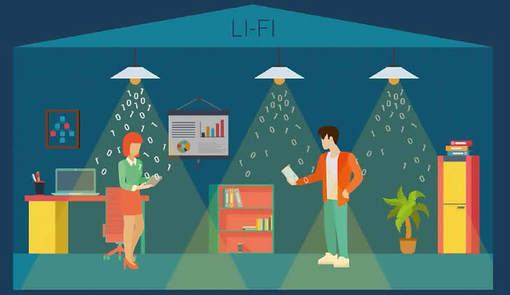
- Li-Fi and Live Streaming
According to a Go-Globe report, 82% of consumers prefer to watch live videos from a brand than posts, 80% of brand audience prefer to watch live video from a brand than read a blog and live videos are watched three times longer than videos that are not live anymore. Because of the rapid rates Li-Fi can reach, it can be made available in big shopping malls, sports stadium, street lights, aeroplanes, trains including underground, train stations, airports and hence. This allows any user to consume rich content media like videos as well as live streaming from their smartphones or other mobile devices nearly anywhere they are like in stadiums, trains and planes provided they are exposed to Li-Fi enabled LEDs. Li-Fi live streaming can also be beneficial for the following type of events:
-Conferences
-Seminars
-Meetings
-Team Building events

-Trade shows
-Business dinners
-Press conferences
-Networking events
-Opening Ceremonies
-Product launches
-Theme parties
-Award ceremonies
-Weddings
-Funerals
-Birthday parties
-Concerts
Li-Fi live streaming has a lot of potentials in many years to come.

- Li-Fi in Hospitals
Because of the non-interference of Li-Fi with radiofrequency devices, Li-Fi can be safely used in many hospital applications. For example, in corridors, waiting rooms, patient rooms and operating theatres, Li-Fi technology will allow a light communication network, which will remove electromagnetic interference issues from smartphones and the use of Wi-Fi in hospitals. Li-Fi can be used for real-time monitoring and report of patient movement and vital signs without the need for wires.
Li-Fi can also enable patients on their beds connecting to internet news, emails, video games and social media platforms through their smartphones. This helps them pass the time during their stay. For medical workers, Li-Fi will enable the tracking and relocation of the positions of critical medical devices, especially those regularly shared by different departments. Check the below diagram for a summary of the benefits of Li-Fi in hospitals.
Oledcomm, one of the leading Li-Fi companies in the world, installed Li-Fi enabled led lights at the Emergency Hospital Centre of Perpignan in 2014. The hospital became the first worldwide hospital with Li-Fi spots in Perpignan. When a patient is admitted to the department and Dr Jean-Marie Bonnec, Emergency Department Head of Perpignan, wants to consult his medical file, he connects to a computer and the Internet. But the wireless connection is made without going through the Wi-Fi network. The wireless connection is made through a Li-Fi system.
Dr Jean-Marie Bonnec stated: " To be mobile between rooms, we are connected in Li-Fi, it is a connection without waves using light waves, thanks to a luminous reception box which will hang the signal on luminous relay terminals which are in the hallway, ".
Li-Fi connection limits the exposure of patients and medical personnel to radio waves.
The Li-Fi technology uses LED light modulated to transmit information to a dedicated receiver that decodes the data on the computer, tablet or smartphone. The transmitter/receiver intercepts the flicker emitted by the bulb and imperceptible to the naked eye.
" We use a conventional box, we get the Internet through the telephone network, the Wi-Fi is off and we send the entire Internet connection through the electricity network to each lamp. The lamp will start to flash more than ten million times a second to transmit a video via Li-Fi, for example, to the laptop. Of course, ten million times, the human eye is unable to see these flickers, but the computer, smartphones, tablets they are capable, " said Suat Topsu, founder of a start-up that wants to meet the technical challenge of" Light Fidelity ".
Impressed by the concept of Li-Fi technology, the IT manager of the Perpignan hospital decided to gradually replace Wi-Fi with Li-Fi.
""In the area where we installed the Li-Fi, we measure 269 millivolts per meter of electromagnetic waves, which is well below the WHO recommendations of 600 millivolts per meter. We still have Wi-Fi, we measure 3 volts per meter, which is ten times higher than we had done in the area equipped with Li-Fi. Our goal is to suppress the waves technologies that allow us to improve the care and health of our users and also our staff because it remains 24/7 within the hospital", according to Vincent Templier, head of the IT department.
Li-Fi technology can also enable robots to deliver equipment and drugs to the departmental wards and different departments in the hospital.
A talking robot named Tug has begun making rounds at St. Elizabeth Healthcare's hospital in Fort Thomas, where it delivers medicine from the pharmacy to nursing stations.
John Giordullo, system director of pharmacy for St. Elizabeth, stated that "The Tug robot allows our pharmacy staff to focus squarely on the clinical and patient-centred parts of their jobs rather than the task of delivering medications through the hospital,"
A software system tracks medication delivery from the pharmacy.

"Tug has been very reliable, predictable and easy to use," said Benita Utz, vice president of nursing for the Fort Thomas hospital. "It has made our jobs as nurses more efficient and has eliminated calls to the pharmacy looking for medication deliveries."
Using a computer, a nurse can see precisely where Tug is at any time.
With the use of Li-Fi, delivery robots can use it to open doors and to call elevators, enabling him to reach all of the patient units in the hospital.
A map of the facility was loaded into the robot's internal computer, enabling Tug to navigate on his own. GPS isn't needed. The robot calculates its location through an odometry algorithm. Sensors, including a laser, detect known and unexpected obstacles, such as people in hallways.
To the amusement of visitors and staff, the robot has raised eyebrows. Powered by an electric motor, the robot rolls along on wheels. It yields to visitors and staff.
When he encounters people, “he announces himself,” Guy Karrick, a spokesman for St. Elizabeth, said. “He’s got a computer-activated voice, the same as if you turn your GPS on in your car.”
The robot also speaks in other circumstances. “Approaching elevator, please stand aside,” Tug says. “Waiting for doors to open.”
Li-Fi based voice-controlled robots are slowly introduced in industries. These robots are used to avoid any accidents that occurred because of workers mistakes. The voice-controlled robot is one of them. By using this robot, workers can control the movements of the robot. The instructions of this operator are transmitted toward robot through Li-Fi technology as such surgical robots can also be implemented.
- Li-Fi in Pharmacies and the Pharmaceutical Industry
In hospital pharmacies and specifically in aseptic manufacturing sites, Li-Fi could be used by pharmacists for receiving and screening electronically approved prescriptions directly in the unit. Li-Fi can be used for real-time tracking of prescribed aseptic drugs like cytotoxic drugs, Parenteral drugs and centralised intravenous additive services (CIVAS) in the unit and nurses and other healthcare professionals from the ward can check the status without the need of calling or going directly to the aseptic unit.
Automation, including automated inspection and packaging, is becoming an increasingly important part of pharmaceutical manufacturing. The many benefits of automation include efficiency, saving workers from hazardous environments or repetitive tasks, reducing training overhead, eliminating human error, increasing repeatability and reproducibility, and in cleanrooms, removing the potential for human contamination.
Through Li-Fi, the access and sharing of patient records will be done in a convenient, faster and very secure manner. For pharmacy dispensaries, Li-Fi could be used by patients to check the real-time status of the prescriptions on their smartphones or pharmacy terminals while waiting to collect their scripts.
Li-Fi can enable data loggers to remotely monitor an environment with periodic data uploads using Li-Fi network without the need of being collected to a PC. Through the Li-Fi system, the data can be collected from any Li-Fi enabled device.
In 2001, the Audit Commission's "Spoonful of sugar" report advocated the use of automation to transform pharmacy services and, since then, many UK hospitals installed dispensary robots. Pharmacy robots have been demonstrated to reduce the incidence of dispensing errors, improve the speed and efficiency of the dispensing process, and optimise the use of space in the pharmacy.
In the UK, the use of robots use in community pharmacies is still limited. However, robots have the potential to handle high volumes of dispensing in community pharmacies or dispensing "hubs", and to release pharmacists to develop and deliver patient-centred services. Li-Fi can enable robots in pharmacies to communicate with staff and other IT systems, delivery of drugs, stock pilling shelves and many more.
As newer, smaller and more efficient machines become available, robot use in all sectors of pharmacy is likely to increase. In addition to that, automated methadone dispensing machines (e.g., Methameasure, Methadose) offer accuracy and efficiency in the laborious methadone dispensing process, and their use will likely increase, too, especially in pharmacies with a high volume of methadone dispensing. Li-Fi will be on the one of the wireless communication technologies that will enable robots to perform their tasks effectively and communicate with other systems and robots.
The Internet of Things (IoT) is currently impacting many industries, including the pharmaceutical industry. Pharmaceutical production processes have to be well-documented to establish and maintain consistent regulatory compliance.
Li-Fi technology can enable pharma IoT connected devices to continuously send data at a very high transmission rate to a server to establish that quality standards are met, which will effectively decrease the amount of manual paperwork and potential margin for error.
- Li-Fi in the Workplace
Li-Fi will not offer illumination but secure wireless connectivity in workspaces. As well as the networking capability, people will be able to take a Skype video conference call and move from one room to another without that conference call being interrupted. Workers and visitors will have a constant internet speed connection from the Li-Fi networks in the workspace. Through light, network access can also be controlled more effectively. For example, the overhead lighting in an office can provide access to the guest network, while desk lamps can provide access to specific parts of a corporate system with access rights assigned on a desk-by-desk basis.
Philips Lighting's LiFi-enabled LEDs are currently being trialling Li-Fi technology in real-estate company Icade's office in La Defense, Paris.
Emmanuelle Baboulin, head of the company's commercial property investment division said: "LiFi has the potential to be a real game-changer in offices. As the leader in our market, we wanted to explore the possibilities of this technology for existing and future clients." "We plan to showcase the technology in our smart office in La Defense, so aside from stable connectivity, the light quality is crucial to us," he added.
Credit to Oledcomm - Summary of Li-Fi application to the workers and the IT department
- Li-Fi in Schools
The right wireless network is a crucial component to provide new learning experiences by connecting students and teachers to smart technology, enabling learning applications on any mobile device. Li-Fi can also provide seamless network connectivity and security throughout the whole school, from the classroom through to university dorms. Some schools have even started trialling Li-Fi technology in classrooms.
A school called The Hegel-Gymnasium in Stuttgart is currently testing Li-Fi in classrooms to teach a broad range of subjects from everything to information technology. In Fraunhofer's prototype Li-Fi installation at the Stuttgart school, lightwaves from LED luminaires wirelessly carry data to boxes that are wired via Ethernet to laptops. Fraunhofer is hoping to move the box's electronics onto a dongle, similar to what pureLiFi is doing. Eventually, the chips should reside inside notebooks, phones, and tablets. The school principal Frank Bäuerle stated that "We are happy that our students are involved with a sensational research project, which is concerned with high-speed data communication without electromagnetic interference. Our teaching staff and students will gather experiences on the level of sophistication of the Fraunhofer HHI VLC-modules, as well as on which pedagogical concepts make sense with this technology. In this way, we will be able to assist in the identification of future technological development."
Pupils in the space – at the Hegel-Gymnasium in Stuttgart – uses modulated light from the LED luminaires to receive data to their devices, an emerging technology known as Li-Fi. Photo credit to Stadt Stuttgart, Yves Schneider.
Last year, The Kyle academy, based in Scotland, started using Li-Fi in the classroom. The Li-Fi project was run in collaboration with PureLiFi and The University of Edinburgh. The installation of pureLiFi's LiFi-XC system consists of eight LiFi-enabled LED light bulbs in the ceiling and students have been given access to LiFi-XC Stations that plug into their laptops, enabling high-speed connectivity through the lights.
The Kyle Academy in Scotland has started trialling Li-Fi in classroom.
Professor Harald Haas stated that "Li-Fi was born in Scotland at a TED Global talk that I presented in 2011. Seven years later, I'm thrilled to see true Li-Fi deployed for the first time in a school in Scotland".

CHAPTER 7
HOW LiFi IS DIFFERENT FROM WiFi

Let's delve deeper into the differences between Li-Fi and Wi-Fi:

- Technology and Operation:
- Wi-Fi: Utilizes radio waves to transmit data between devices. It operates within the radio frequency bands, typically 2.4 GHz and 5 GHz.
- Li-Fi: Relies on light waves, specifically visible light communication (VLC), for data transmission. It modulates the intensity of LED bulbs to encode and transmit data.

- Data Transmission Speeds:
- Wi-Fi: Offers data rates ranging from a few megabits per second (Mbps) to several hundred Mbps, depending on the Wi-Fi standard (e.g., 802.11n, 802.11ac).
- Li-Fi: Demonstrates the potential for much higher data rates, reaching into the gigabits per second (Gbps) range. This is due to the broader available spectrum in the visible light range, enabling faster data transmission.

- Security:
-Wi-Fi: Security mechanisms such as WPA2 encryption help protect data transmitted over Wi-Fi networks. However, Wi-Fi signals can potentially be intercepted by unauthorized parties within range of the network.
- Li-Fi: Offers enhanced security features compared to Wi-Fi due to the physical limitations of light propagation. Since light cannot penetrate walls, Li-Fi signals are confined to the space illuminated by the light source, reducing the risk of interception by outsiders.

- Interference and Range:
- Wi-Fi: Can penetrate walls and other obstacles, allowing signals to propagate over longer distances. However, Wi-Fi signals are susceptible to interference from other electronic devices operating in the same frequency bands.
- Li-Fi: Signals are confined to the area illuminated by the light source, limiting the range of transmission. Li-Fi signals can be affected by obstacles blocking or attenuating the light, as well as interference from ambient light sources.

- Applications:
- Wi-Fi: Widely used for wireless internet access in homes, businesses, public spaces, and mobile devices.
- Li-Fi: Suited for environments where high-speed data transmission and enhanced security are critical, such as hospitals, industrial facilities, and secure government installations. Li-Fi can also complement Wi-Fi in areas with high data demand, providing additional bandwidth.

- Challenges:
- Wi-Fi: Faces challenges related to congestion in the radio frequency spectrum, especially in densely populated areas.
- Li-Fi: Must overcome challenges such as limited range, susceptibility to interference from ambient light, and the need for line-of-sight communication between transmitters and receivers.

In summary, while Wi-Fi and Li-Fi both offer wireless connectivity, they operate on different principles and cater to distinct use cases. Wi-Fi excels in providing widespread coverage and mobility, while Li-Fi offers the potential for higher data speeds and enhanced security in specific environments. Both technologies continue to evolve, and their respective strengths and limitations shape their applications in various industries and settings.

CHAPTER 8
CONCLUSION

Conclusion:
Based on the results presented in previous sections, following conclusions have been observed:
In summary, LiFi emerges as a compelling contender in the realm of wireless communication, leveraging light waves to transmit data with notable advantages over conventional WiFi technology. Its introduction into the market signifies a significant milestone in the ongoing evolution of connectivity solutions. By harnessing light for data transmission, LiFi offers inherent security benefits, as light signals are confined within physical spaces, reducing the risk of interception or hacking compared to radio frequency-based WiFi signals.
Moreover, LiFi’s reliance on light waves minimizes electromagnetic interference, making it an attractive option for environments sensitive to RF interference, such as hospitals, industrial facilities, and aircraft cabins. The technology’s ability to operate in parallel with existing lighting infrastructure presents a cost-effective and space-efficient solution for implementing high-speed wireless connectivity in various settings.
However, it’s important to acknowledge LiFi’s limitations, including its reliance on line-of-sight communication and susceptibility to interference from ambient light sources. These constraints may pose challenges in scenarios where uninterrupted data transmission is critical or in environments with fluctuating lighting conditions.
Nevertheless, LiFi’s potential applications span a wide range of industries, from smart homes and offices to transportation and healthcare. Its unique characteristics make it particularly well-suited for use cases such as indoor positioning, where precise location data is essential, and automotive communication, where high-speed, reliable connectivity is paramount for safety and efficiency.
In contrast to WiFi, which operates on radio frequencies, LiFi represents a paradigm shift in wireless communication by capitalizing on the abundant and untapped spectrum of visible light. This fundamental difference opens up new avenues for innovation and exploration in the field of connectivity, paving the way for a future where light becomes synonymous with data transfer.
As ongoing research and development efforts continue to refine LiFi technology and address its current limitations, the potential for widespread adoption and integration into everyday life becomes increasingly feasible. With its unique blend of advantages and innovative approach to wireless communication, LiFi stands poised to revolutionize the way we connect, communicate, and interact in the digital age and beyond.

